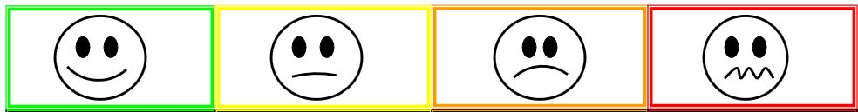
Safe and  Respectful  Choices  adults:  Remember to give lots of praise when you see behaviors you are looking for | I Need a reminder  adults:  if you start seeing frustration, try redirecting behavior and talking about feelings  validate your child’s feelings | Warning  Adults:  Kneel down to child’s level and get eye contact and tell them if they continue the behavior they will get a consequence  **If they hit, they go right to orange | Consequence  Adults:  Follow through on the consequence you warned them about in the orange section.

Awesome | LEVEL 1 | Level 2 | Level 3
Safe and  Respectful  Choices | I Need a reminder  Whining  Not listening  Interrupting  Showing frustration | Warning  Physical aggression  Disobeying rules  Unsafe choices | Consequence  (time out)  Level 2 behaviors keep repeating

